

Module 8 Network Access

# Beginner Question

* 1. Explain Switch
     1. **Switch is an electrical component that can disconnect or connect the conducting path in an electrical circuit, interrupting the electric current or diverting it from one conductor to another**.
  2. Explain Switch Boot Sequence
     1. **It tests the CPU, DRAM, and the portion of the flash device that makes up the flash file system**. Step 2. Next, the switch loads the boot loader software. The boot loader is a small program stored in ROM and is run immediately after POST successfully completes.
  3. Explain Three Methods to access Switch Command Line Interface
     1. A command-line switch is **a modifier that is added to the .exe file**. A startup file with a switch looks like this. outlook.exe /nopreview. In this example, a command-line switch has been added to the .exe file for Microsoft Outlook.
  4. Explain and Configuring the Cisco Internet Operating System
     1. Cisco is a proprietary operating system that runs on Cisco Systems routers and switches. The core function of Cisco IOS is to enable data communications between network nodes.
  5. Explain Switch Port
     1. It sends data packets to designated destination ports using MAC addresses (addresses of the media access control sublayer). It receives and forwards data packets from the source to the destination device using the packet switching technology.



C:\Users\Android\Desktop\switches-ws-c2960-24pc-l_front.jpg

* 1. Configure Basic Password Settings on a switch
  2. Configure Line Password Settings on a switch
  3. Configure Password Settings on a switch
  4. Configure IPv4 on a switch 10.Verifying IPv4 on a switch

A. DONE ALL 11.Explain Basic V LAN

A. A virtual local area network (VLAN) is **a virtualized connection that connects multiple devices and network nodes from different LANs into one logical network**.

1. Explain VTP
   1. VTP is a Cisco proprietary protocol used by Cisco switches to exchange VLAN information. With VTP, you can synchronize VLAN information (such as VLAN ID or VLAN name) with switches inside the same VTP domain.
2. Explain CDP.
   1. . It collects and unifies first-party customer data from multiple sources to build a single, coherent, complete view of each customer.
3. Identifying VLAN
   1. To identify which VLAN the traffic belongs to, all frames on an Ethernet VLAN are identified by a tag, as defined in the IEEE 802.1Q standard. These frames are tagged and are encapsulated with



802.1Q tags.

1. Describe the basic operation of STP
   1. STP was created to avoid the problems that arise when computers exchange data on a local area network (LAN) that contains redundant paths.
2. Explain IPv4 subnetting.
   1. **IPv4 allows for a variation of the network and host segments of an IP address**, known as subnetting.
3. What is subnet mask?
   1. Every single computer that is connected to a subnet shares an identical portion of the IP address. This shared information is known as a routing prefix, and in IPV4 (Internet Protocol Version 4), **the routing prefix** is called a subnet mask.
4. Explain binary decimal hexadecimal with example
   1. Every single computer that is connected to a subnet shares an identical portion of the IP address. This shared information is known as a **routing prefix**, and in IPV4 (Internet Protocol Version 4), the routing prefix is called a subnet mask.
5. Describe the Need for Public IPv4 and Private IP Addressing

A.A private IP address is used within a private network to connect securely to other devices within that same network.

1. Explain Subnet Prefix
2. Configuration basic IP address in fig.
   1. DONE

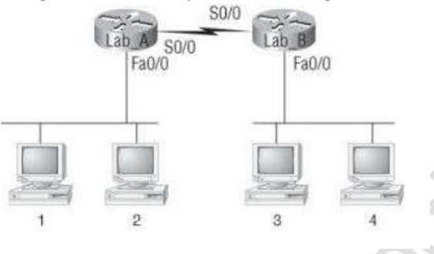



23. Create Static Routes

A. DONE



# Intermediate Question

1. Explain Logging into a Switch
   1. Go to the Nintendo Account website or open the application where you want to sign in. Enter the sign-in information that you used to create your Nintendo Account: For Nintendo Account sign in - Enter the email address and password associated to your account, then select "Sign in".
2. Explain Switch User Mode, Enable (Privileged) Mode and Global Configuration Mode
   1. User Mode allows the user to have access to some particular monitoring commands. Privileged Mode is a password-protected mode that can be only accessed by the authorized user and configured with all the commands.
3. Gathering Switch Basic information
   1. **when the power supply wire moves from one switch to the second switch and finally terminates at the fixture**. This wiring diagram shows both switches aligned together with the fixture at the end.
4. Explain SSH
   1. Secure Shell is used to **connect to servers, make changes, perform uploads and exit**, either using tools or directly through the terminal. SSH keys can be employed to automate access to servers and often are used in scripts, backup systems and configuration management tools.
5. Configure SSH Setting On a Switch

A. DONE

1. Explain Telnet Setting
   1. Telnet is a network protocol used to virtually access a computer and to provide a two-way, collaborative and text-based communication channel between two machines.
2. Verifying Switch Interface Status

A. DONE

1. Configure VLAN

A. DONE

1. Verifying VLAN

A. DONE

1. Configure VLAN Trucking

A. DONE

1. Give Reasons for Using VLANs A.VLANs can be used for different groups of users, departments, functions, etc., without needing to be in the same geographical area.
2. Static VLANs
   1. VLANs and dynamic VLANs is that the static VLANs are

configured manually by assigning ports to a VLAN

1. Dynamic VLANs
   1. dynamic VLANs use a database that stores a VLAN-to-MAC mapping to determine the VLAN that a particular host is connected to.
2. Brief explain STP Timer
   1. Default Spanning Tree Protocol (STP) forward delay timer is 15 seconds. You can adjust the Spanning Tree Protocol (STP) forward delay timer to any value between 4 and 30 seconds.
3. Explain how Switches Calculate Their Root Cost A.When a switch receives the BPDU, it adds the ingress port cost of the segment to determine its internal root path cost.
4. Configure STP on Switch

A. DONE

1. Verifying STP on a Switch

A. DONE

1. What is Port Security how to find Port with command? A.When a link goes down, all dynamically locked addresses are freed. The port security feature offers the following benefits: You can limit the number of MAC addresses on a given port.
2. Classified Default subnet mask for Class A, B, C, D
   1. The three default subnet masks are **255.0. 0.0 for Class A,**

**255.255. 0.0 for class B, and 255.255. 255.0 for Class C**. D. is undefined

1. Explain Classless Inter-Domain Routing?
   1. This method of routing adds class-C Internet Protocol (IP) addresses. These addresses are given out by Internet Service Providers (ISPs) for use by their customers.
2. How to define subnetting address of class A, B, C, D

A.Subnet addressing **allows an autonomous system made up of multiple networks to share the same Internet address**. The subnetwork capability of TCP/IP also makes it possible to divide a single network into multiple logical networks (subnets).

1. Explain Classless and Class full Addressing
   1. Classful addressing is a technique of allocating IP addresses that divides them into five

categories. Classless addressing is a technique of allocating IP addresses that is intended to replace classful addressing in order to reduce IP address depletion.

1. Details of VLSM (variable length Subnet Mass
   1. This process of "subnetting subnets" enables network engineers to use multiple masks for different subnets of a single class A, B or C network.
2. Explain Static Routing
   1. static route are created in globe config mode, and require a destination prefix and a way to get there.
3. Explain Default Routing
   1. If multiple default routes are configured, the appliance will randomly pick which interface to use for outbound traffic if a more specific route cannot be found.
4. Configuring IP routing
   1. DONE



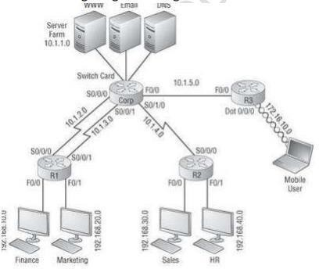

27 Configure VLAN Routing

1. DONE
2. Routing Protocol Metric
   1. DONE
3. Explain how OSPF calculates the cost for a route
   1. OSPF uses a cost metric that represents the status of the link and the bandwidth of the interface in an algorithm to determine the best route to a destination.
4. Define Benefits and Uses of IPv6

## IPv6 supports multicast addresses, meaning bandwidth-intensive packet flows like media streams can reach many destinations simultaneously

1. Define this IPV6 Address
   1. IPv6 was developed by the Internet Engineering Task Force (IETF) to deal with the long-anticipated problem of IPv4 address exhaustion, and is intended to replace IPv4. 32.Explain IPv6 Routing Protocols

A. Routing in IPv6 is almost identical to IPv4 routing under

CIDR. The only difference is the addresses are 128-bit IPv6 addresses instead of 32- bit IPv4 addresses.

# Advance question

1. Setting administrative factions
2. Setting hostnames
3. Setting banners
4. Setting passwords
5. Viewing, saving, and erasing configurations

A. DONE ALL



1. Configure an IP address on a switch
2. Configuring SSH
3. Configuring Telnet

A. DONE ALL

1. Explain Layer 3 Switch
   1. **The Layer 3 switch looks like a switch. It has 24-plus Ethernet ports and no WAN interfaces. The Layer 3 switch will act like a switch when it is connecting devices that are on the same network**.
2. Describe Dynamic IP configuration with DHCP
   1. Dynamic IP configuration, client device lease an ip configuration from a dynamic host configuration protocol {DHCP} server.
3. Explain 802.1q Protocol
   1. **802. 1Q is the networking standard that defines virtual LANs [VLANs] on an Ethernet network.**
4. Explain the Switch Port Mode Command

## Puts the interface into permanent trunking mode and negotiates to convert the neighboring link into a trunk link.

1. Explain the Removing Command of VLAN A.To remove VLANs from a physical port, complete the following steps. From global configuration mode, enter interface Ethernet configuration mode.
2. Describe Inter VLAN Routing
   1. VLANs make it easier for one to segment a network, which in turn improves the performance of the network and makes it more flexible, since they are logical connections.
3. Explain Dynamic Routing

A. Dynamic routing is a mechanism through which routing information is exchanged between routers to determine the optimal path between network devices.

1. Explain routing loop

## They are formed when an error occurs in the operation of the routing algorithm, and as a result, in a group of nodes, the path to a particular destination forms a loop.

1. Configure and verify inter switch connectivity

A. DONE

1. Configure and Verify VLAN Trucking

A. DONE

1. Explain and configure PAGP

## Port Aggregation Protocol (PAgP) is a Cisco proprietary protocol which is used for the automated, logical aggregation of Ethernet switch ports, known as an Ether Channel. 20.Configuring Ether Channel

A. DONE